**3rd Grade Supply List for the 2023-2024 School Year**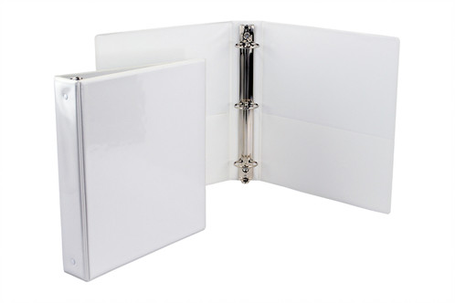



* **2 inch, 3 ringed binder**
* **5 color dividers**
* **Headphones or earbuds**
* **Spiral Notebook (no composition books)**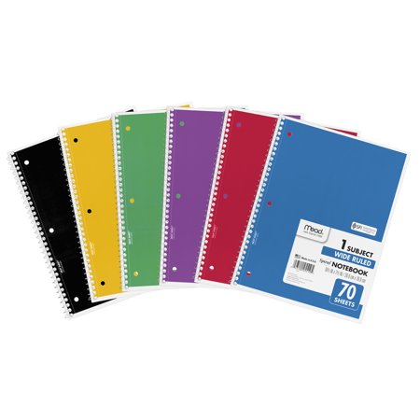
  + 1 red spiral notebook (reading)
  + 1 blue spiral notebook (social studies)
  + 1 yellow spiral notebook (math)
* **Three-prong, two-pocket folders** 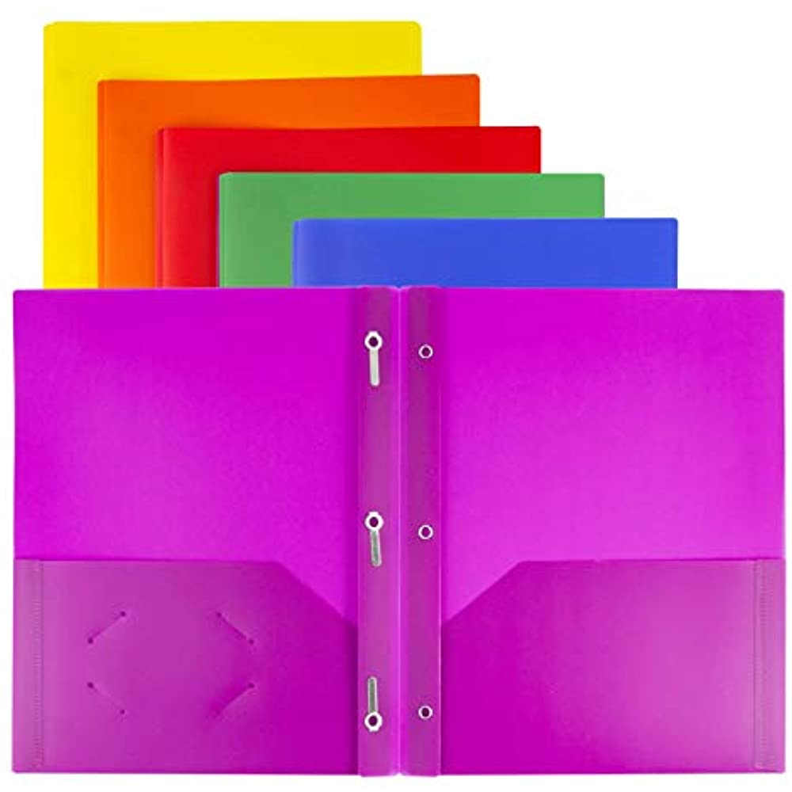

**(plastic will last all year)**

* + 1 blue folder (classwork)
  + 1 black folder (take home folder)
  + 1 green folder (science/STEM)
* 1 refillable water bottle
* 4 glue sticks
* 8 **black** expo markers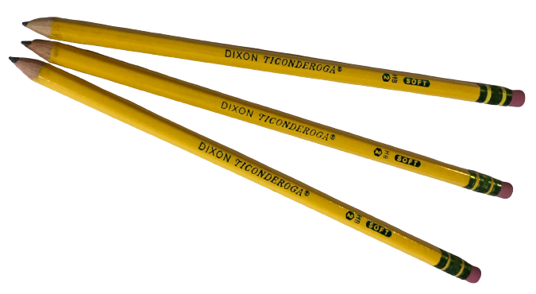
* 4 highlighters
* 2 dozen #2 pencils **(no mechanical pencils)**
* 2 pink erasers
* 1 box eraser toppers
* 2 packs of sanitizing wipes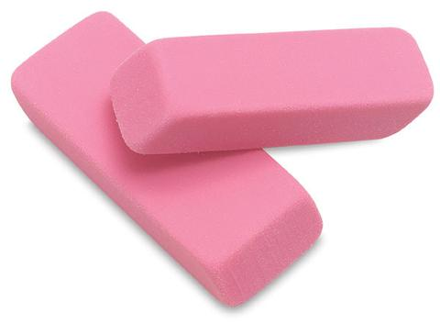
* 2 boxes of tissues
* 2 reams of copy paper
* Ziplock Bags Last Name A-L Quart Size Bags
* Ziplock Bags Last Name M-Z Gallon Size Bags